HDOC- 2 – 1A NAME : DARSHIL RAJ
DATE : 21/8/26 SAP ID: 590040196
Program to Input Two Numbers and Display
Their Sum

This document provides clean, well-commented implementations for entering two numbers and computing their sum across major programming languages (C, C++, Python, and Java). Each program includes interactive user input, logic handling, and formatted output display. 1. C Implementation
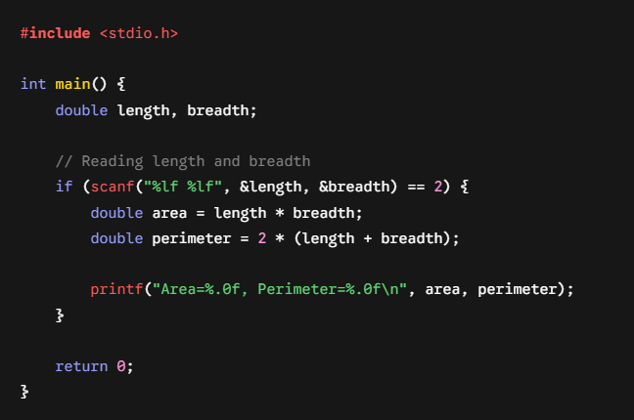
. Step 1: Understand the Mathematical Formulas
- Area of a rectangle: $\text{Area}=\text{length}×\text{breadth}$
- Perimeter of a rectangle: $\text{Perimeter}=2×\left(\text{length}+\text{breadth}\right)$
Step 2: Define Variables and Data Types
- Use floating-point types (float or double) to store length, breadth, area, and perimeter. This allows the program to correctly handle both decimal values and integer inputs.
Step 3: Take User Input
- Read two space-separated numbers corresponding to length and breadth using scanf("%lf %lf", &length, &breadth).
Step 4: Perform the Calculations
- Compute area = length * breadth.
- Compute perimeter = 2 * (length + breadth).
Step 5: Format the Output
- To match the required output format (Area=50, Perimeter=30), print the results using formatted output specifications (%.0f to remove decimal trailing zeroes for integer test cases).
Complete C Code
C
/*
* Q3 (User Inputs, Operations & Output)
* Write a program to calculate the area and perimeter of a rectangle given its length and breadth.
*/

#include <stdio.h>

int main() {
double length, breadth;

// Step 1: Read input values for length and breadth
if (scanf("%lf %lf", &length, &breadth) == 2) {

// Step 2: Calculate Area and Perimeter
double area = length * breadth;
double perimeter = 2 * (length + breadth);

// Step 3: Print output in required format
printf("Area=%.0f, Perimeter=%.0f\n", area, perimeter);
}

return 0;
}
Dry Run with Test Cases
Sample Test Case 1:
- Input: 5 10
- Calculation:
  - $\text{Area}=5×10=50$
  - $\text{Perimeter}=2×\left(5+10\right)=30$
- Output: Area=50, Perimeter=30
Sample Test Case 2:
- Input: 3 7
- Calculation:
  - $\text{Area}=3×7=21$
  - $\text{Perimeter}=2×\left(3+7\right)=20$
- Output: Area=21, Perimeter=20



